<GitHub>
<Game catch phrase>

Design Document
(Homework No.2)

Project team: <Team Name>
Instructor: Dr. Araz Yusubov

Submitted in partial fulfillment of the requirements of the CSCI 4836: Game Development Fundamentals course project

Version date | Version information
<Date> | Initial draft
<Date> | <Version description>

Other documents in the package
File name | Brief description of the document
<File name> | <Description of the document>
<File name> | <Description of the document>

Team member | Contribution to this homework (NOT the project) | Estimated %
<Student Name 1> | <Description of the work contributed> | <X>%
<Student Name 2>
<Student Name 3>
<Student Name 4>

Table of Contents
<Automatically generate here using Microsoft® Word menu References→Table of Contents>

<This document describes how game objects behave, controlled and properties they have. This is often referred to as the “mechanics” of the game. This documentation is primarily concerned with the game itself. This part of the document is meant to be modular, meaning that you could have several different Design documents attached to the Concept Document.>

Introduction
This is part of the Game Design Document for a hypothetical project <Game Project Name> submitted for partial fulfillment of the requirements of the Game Development Fundamentals course in the School of Information Technologies and Engineering at ADA University, Baku, Azerbaijan.
Since, shooter gaming is most popular genre among the video game players, we decided to choose this genre. Users of our game are going to fight against the bots via shooting snowballs to them. Main players will have different abilities based on their roles. Our game will have gloomy atmosphere in order to catch the player’s more attention. In our map 3D models such as buildings of ADA University, Flame towers of Azerbaijan will be included. Our players have to defeat each “snowman” to access new levels. This game basically is going to be “nationalized” version of the Snow Craft. [1]
After the starting Frozen Summer game the user will be able to see his/her nickname, list of the characters, game sound settings, etc. in the main menu.
When the user starts to play, he/she will begin with low difficult level. In order to survive in our game character must avoid shootings from snowball and finish them in a given time.
Since our game is going to have 3 different levels, difficulty is going to change accordingly.
For instance, in next levels given time to finish the snowmen will decrease and power of the snowmen will increase. Our game will have life level bar, when it reaches below the certain level, movement ability of the character will decrease and as soon as life level bar reaches the zero, game will be over. The user have to start from first level when his/her character dies.
The game will be non-violent, so there is not going to be blood, or other graphic content while playing against the bots.

Player Elements
<The player elements section lists all the elements that are directly related to the player or serve to benefit of the player. Devise two sets of names for player elements. One set is a generic name (or code) and the other is its game name. Describe the terminology that you use to describe the player’s properties.
This is a good place to interact with a graphic designer to ensure the game graphics match the game names. Graphics that will be seen during game play should be exhibited here. Multi-player issues should also be mentioned here.>

Player Definition
<Use the player definition section to make quick descriptions that define the player.
Below is a suggested list of player definitions:
- Default (Status): What are the default settings for the player at the beginning of the game or level?
- Actions: What can the player do?
- Information (Status): What information about the game is available for the player?
- Default Properties: How does the player begin the game?
- Winning: How can the player win?
- Loosing: How does the player lose?
>

Player Properties
<Make a list within the player properties section that defines the properties for each player. Player properties can be affected by player’s action or interaction with other game elements. Define the properties and how they affect the player’s current game. A suggested list of player definitions may include:
- Health
- Weapons
- Actions
- Etc.
Each property should mention a feedback as a result of the property changing.>

Player Rewards (Power-ups & Pick-ups)
<Within the player rewards section, make a list of all objects that affect the player in a positive way (i.e. health replenished). Define these objects by describing what affect they cause and how the player can use the object.>

User Interface (UI)
Even though the buttons for the game could be changed from the main menu or inside the game with entering the options, there are some default buttons that specially allocated to some actions. All preselected keys are chosen particularly to be coherent with most of the games in the market, which is designed to ease the learning process for both newbies, and experienced players. Moreover, most of the computer manufacturers are producing the keyboards for this kind of games, and we are planning to use from this advantage [1]. The keys are divided into two main groups: mouse keys and keyboard keys. The list of buttons can be find above:

Keyboard

W or Up Arrow– to move player from down to up in the screen.

S or Down Arrow – to move player from up to down in the screen.

A or Left Arrow – to move player from right to left in the screen.

D or Right Arrow – to move player from left to right in the screen.

Mouse

Direction of the Mouse – to turn the character.

Right Click – to shoot the snowballs to the directed side.

Left Click – to use the Ulti (might be different for various characters)

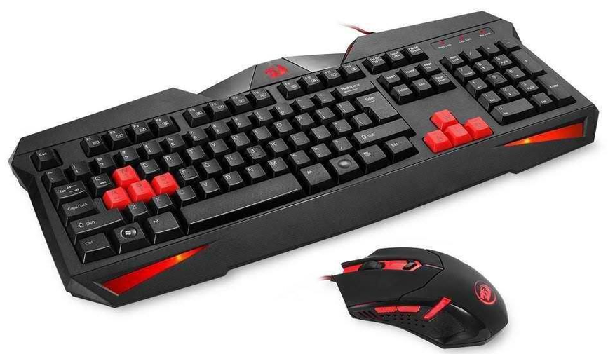
https://media.takealot.com/covers_tsins/45051305/reddragonbundle-zoom.png

Heads up Display (HUD)

HUD is turned to be significant part of the game itself, and nowadays almost all of the game companies are using the all-important elements in the screen in order to simplify the work of the player, and our game - “Frozen Summer: Oghuz Edition” is no exception. Besides the characters and other objects in the game, gamers will be able to see some game changing factors in the monitor, here are the list of some of them[2]:
Health Bar – health bars will be visible for not only chosen player but also other enemies.

Ulti Bar – this bar can be different in variety of characters.

Number of Snowballs – this bar is also can vary in different characters.

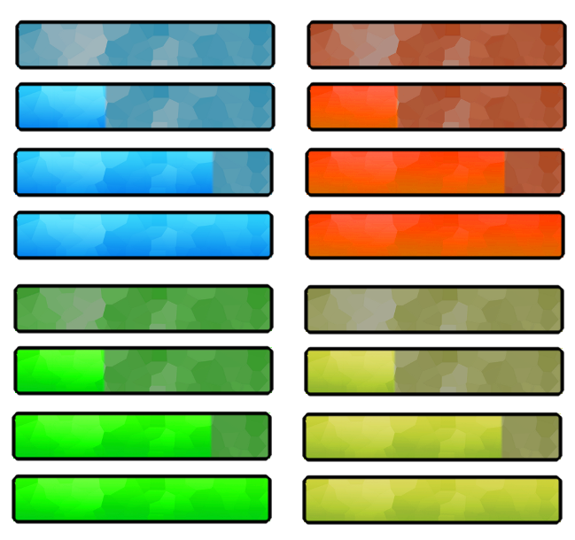
https://i.pinimg.com/originals/3b/97/fc/3b97fc1a260d4b810c7581b97e228fef.png

Player View
Actually, our game is planned to be in the TPs view, which stands for Third-Person Shooter, and as name suggests our main camera will not be showing the same scene from the characters eyes, the gamer will be able to see from the top of the character, and even whole body of the character will be visible. Furthermore, throughout the game our main camera will be following the selected character(in this case it is our character), and some minor zooming in and out may be seen in the starting of the game and in the final scene.

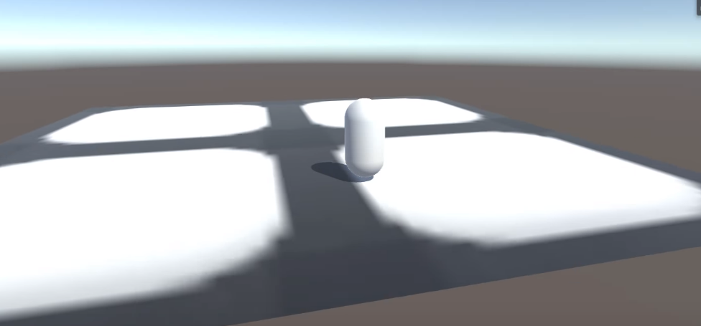

Antagonistic Elements

In our newly developing game - Frozen Summer: Oghuz Edition, there will be several antagonistic elements. In the game, if the gamer is trying to create new game, he or she has to choose one of the main characters, including Basat (001), Beyrek (002) and Bay Beycan (003). However, players are free to choose their game names themselves. In the game, as it is mentioned, user must choose one of the hero; therefore, none of the aforementioned characters cannot be faced during the gameplay. However, they will have some enemies which will try to obstruct and stop them throughout the game. For instance, the Snowmen (008) in the game will always throwing the snowballs towards the player. Moreover, the main enemy of our hero – Simnar Khan (004) is another antagonistic element in our game.

Antagonistic Definitions

In our game, the list of characters that can be chosen by gamers is not enemy to each-other. They cannot be face during the game, while other antagonistic elements, in our case they are Snowmen and Simnar Khan, are always trying to stop our main hero. They always throw snowballs in the game. Not only them but also our main hero are always throw snowballs, therefore all of them can be considered as an antagonistic elements.

Antagonistic Properties
In the game all alive properties will have some common properties. These common properties will be more or less same for all antagonistic elements in the game, while some of the characters will have variety of special skills. Health and number of snowballs in the both enemy and our hero can be good example for this kind of property.

Antagonistic List

Element ID | Name | Description
001 | Basat | One of the game characters that have special ability to move fast
002 | Beyrek | A game character that can shoot multiple snowball at the same time
003 | Bay Becan | A game character that have powerful snowballs
004 | Simnar Khan | Main enemy in the last level that have highest power
008 | Snowmen | Soldiers of the Simnar Khan

Artificial Intelligence (AI)
<Nowadays almost all of the game factories are using AI to make their games more interesting, and without it none of the games can be imagined. Our game is also no exception in terms of AI usage, and in the behaviors of the antagonistic elements we are planning to use AI. All of the above-mentioned states are for Snowmen which are main opponents of the gamer, and will be controlled by the computer with help of AI:
- Normal State: If the enemies are far away from the main hero, they will be in the normal state. This state also can be considered as an idle state, because in this state enemies are not doing anything but walking without any damage.
- Detection State: In the game snowmen are humanlike elements, while their eyes are not as good as normal person, therefore they only can detect our here if it enters the vision range of snowmen.
- Reaction State: If the character is in the vision range, and detected by the arbitrary snowman, they will immediately be under attack of the snowmen. Snowmen will start moving towards the hero and start to throw snowballs.
- End State: After snowball fight either hero or snowmen will win the fight, in case of their winning snowmen will pass to idle state again and game will be finished for the gamer.

Global Game Elements
<In this section, it is important to describe the boundaries, neutral objects, camera views and scale of the world. Neutral game world objects can be things like a static background, objects that do not interact with the player or antagonistic elements.>

The Story
<This is where the story can be described in detail. A story board can be used to tie in graphics to the text. This can later be used for splash screen concepts.>

The Story Copy
<A shorter version of the story (the in game version) should also be written here. This is where the script for in game characters or story information during the cut scenes would be placed. This category does not always pertain to the current Game Design.>

Concept Art
<Sketches that are used for the concept can go into this section as visual reference. In the case of a brand, certain creative restrictions should be noted here. This is a good place to collaborate with a graphic designer to ensure game graphics match game names.>

Level Design
<This is where information pertaining to level design and visuals of the level design goes. Level design can best be shown as a flow chart. Use generic names to create level design.>

Level Copy
<This is where the script for in game characters or story information during the cut scenes would be placed.>

Audio & Sound F/X
<This is where game audio and Sound F/X should be listed, first with generic names and then described. This section also includes deciding if you will use a device’s vibration ring mode.>

Game Architecture
<The game architecture section is best produced using a flow chart to represent the overall game. Be sure to identify (i.e. name, number) each screen.
- Title Screen
- Option Screens
- Game Modes
- End Screens
>

Game Architecture Overview
<The splash screens or video clips need to be in accordance to game story and style. If cut scenes use video then story boards should be created.
Menus should be designed with the most important options easily accessible. Be aware how many clicks it takes to accomplish a task. The game Instructions should be written so that the player understands how to play the game. Mock-ups should be made so that the game programmers get the correct layout of the menu. It is a good idea to mention and describe the high score screen in this section.>

Architecture Copy
<All text from the game can be compiled here. Review the Game Architecture Overview section.>

How to Play Copy
<This section will organize the game copy. The game copy includes information for the player, clearly describing how to play the game.>

References
<Insert here any document referred to in the document. An example might be articles or Web sites that you consulted during the literature search. This is not just a list of used materials, so do not forget to clearly MARK the exact points(s) of reference in the main text.>

